Knowle DGE Academy

Pupil Induction information



All Equal, All Different, All Achieving Together

Our Values and Ethos as an Academy

We believe that each student will DISCOVER new learning opportunities and experiences at Knowle DGE. Together, with your support, we will GUIDE each student towards these learning opportunities and in doing this we are confident that each student will ENJOY their learning experiences at Knowle DGE.

In order to succeed, we aim to encourage every individual at our Learning Centre to develop BELIEF in themselves to aim higher, to RESPECT themselves, others and their Academy and take RESPONSIBILITY for their decisions and actions.

We recognise that we are ALL EQUAL and deserve the very best. We recognise that we are ALL DIFFERENT in the ways we learn and interact. We recognise that we can ALL ACHIEVE TOGETHER – as an Academy, as a pupil within the community and as a parent / carer.

Useful Contact Information

Academy Telephone Number: 0117 3708030

Academy Email: school@knowledge.mnsp.org.uk
Academy Website: www.knowledgeacademysch.org.uk/

Academy X (Twitter): knowle_dge

Academy Postal Address:
Knowle DGE Academy, Novers Road Knowle, Bristol, BS4 1QY

Chair of Governors
Mr Ben Moss

CEO
Mr Alun Williams

Executive Head
Mrs Sophie Addison

Head Teacher
Mrs Kate Lee-Wells

Deputy Headteacher
Mr Nick Lee-Wells

Assistant Headteachers
Mr Matt Franzke
Miss Suzanne Nelson
Mrs Jenny Hughes

Administration:

Office Manager Mrs Lou Shepherd
Estates Manager Mrs Donna Bidder

Useful Contacts:

SENDCO Mr Nick Field
Speech & Language Specialist ‘Child Speech’
Educational Psychologist From Bristol and South Glos LEA.
School Nurse From SIRONA

Heads of School:
Lower Mrs Hannah Harrold
Mr Robert Baker
Middle Ms Tamsin Karim
Mr Craig Caradine

Upper Mr Matt Carroll
Mrs Jayne Townsend
Mr Mark Scott

Academy Information:

The Academy hours are:

Monday to Friday 8.45am to 2.30 p.m

Lunches:
Lunches are cooked freshly on the site and a choice of hot and cold dishes are provided including vegetarian meals. We are a healthy Academy and offer a good choice of healthy menu options throughout each week. To further promote healthy eating, we discourage our pupils from consuming sweets or fizzy drinks.
Thanks to the commitment of the teaching staff there is a good level of supervision during lunchtime and at break times. A range of activities inside and outside are provided.

Academy lunches are charged at:

Free for Reception and year 1 & 2 (Must be registered with free school meals)
£2.25 for students in years 3 to 6
£2.40 for students in years 7 to 11

If you are entitled to free school meals, please complete the ‘free school meals’ form with the Academy office.

Breakfast Club:

We are able to provide all of our pupils the opportunity to have breakfast during morning registrations. Breakfast offers our pupils cereal, toast, fruit and juice.

Uniform:

We expect pupils to wear the school uniform. We provide the first polo shirt free of charge.

School Uniform
A Knowle DGE polo shirt (Navy)
A Knowle DGE sweatshirt or fleece (no hood)
Black trousers or joggers
Black Shoes or trainers

6th form have their own dress code

P.E. Kit
A navy Knowle DGE t-shirt
Navy/Black shorts/joggers
Trainers (no black soles are permitted for indoor P.E. lessons)

Trousers and shorts can be purchased from supermarkets such as ASDA or Tesco. Branded school wear is available for purchase directly from school. All the garments offer excellent value for money and are made from hard wearing, machine washable fabrics, embroidered with our logo.
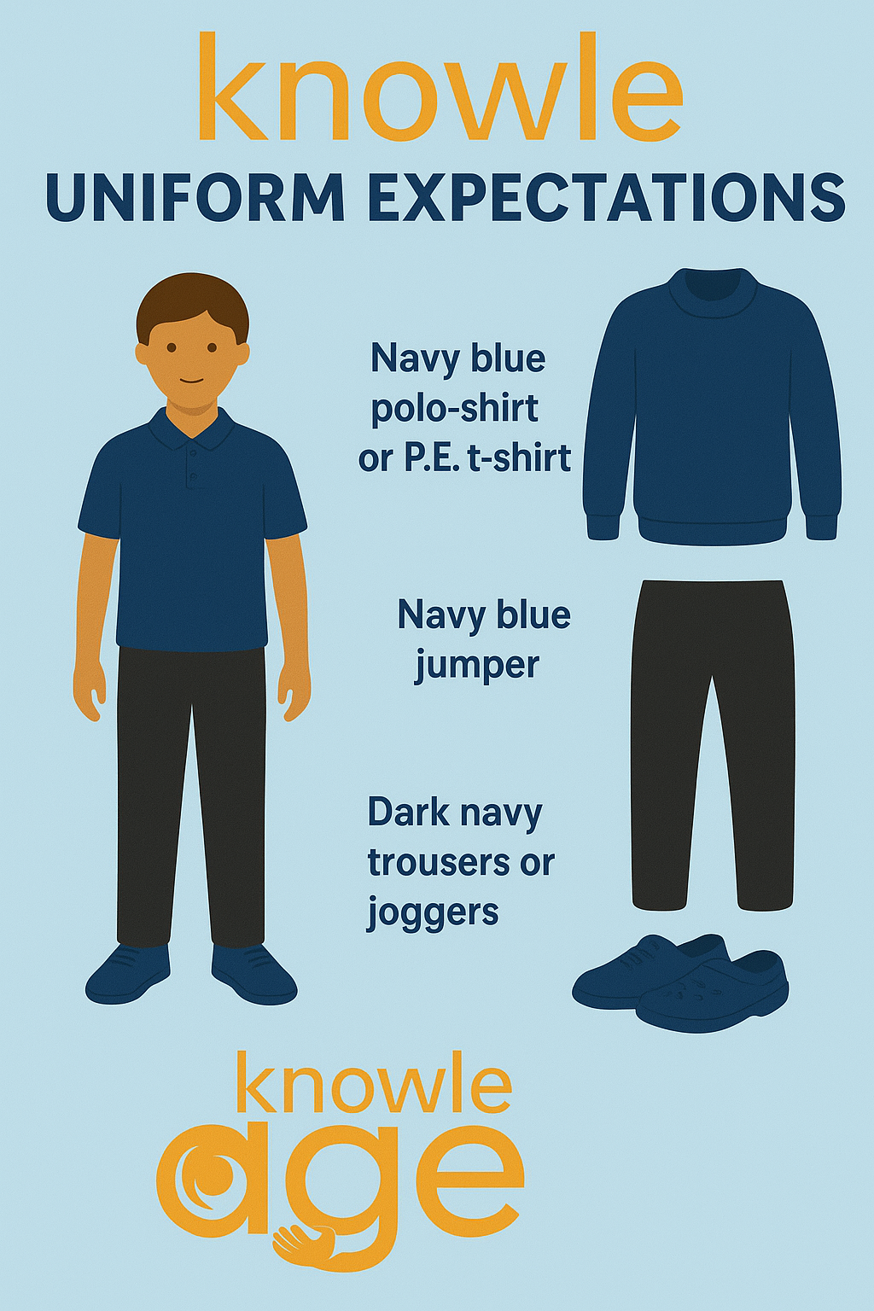
Arrivals and Departures:

Pupils arrive at the pupil reception entrance of the Academy where staff are able to greet them from 8.45 am. Staff will direct pupils to the appropriate entrances (according to key stage). Registrations will take place up until 9:00am when registration closes. Pupils arriving after this period will be recorded at front reception.

At the end of the day, pupils will exit the building from the appropriate exit and make their way towards buses and public transport at the front of the Academy.
Pupils are encouraged to be independent travelers to and from the Academy; however, bikes, scooters, roller blades or skateboards are not permitted in the Academy building. We provide specialist storage for pupil’s transport, where it must be dropped off before morning registrations and picked up at the end of the Academy day.

Knowle DGE Terms Dates and Holidays
Term dates will shortly be available on the school website.

Communication

Staff will tend to call to relay key information about your child. Generally information is communicated via the Arbor App. You can use the app for reporting absence, messaging and choosing meals. A login email has been sent to you. Please let your tutor know if you would like it sent again.



Additionally, In Lower and Middle school DoJo is used where you can see your child’s points and get key messages.
If you use social media we also have a closed Facebook group and update news on twitter. If you would like to join please follow the link or use the QR code.
https://facebook.com/groups/593380846091379/

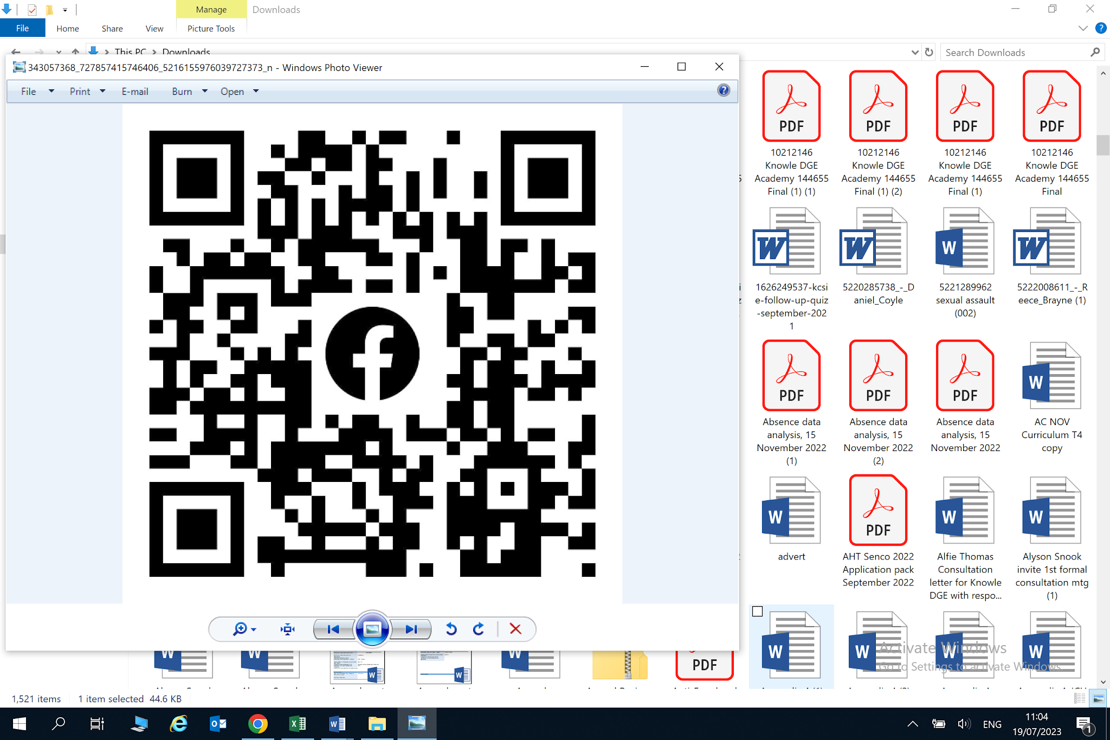

Specialised Subjects and Requests for Contributions

At times subjects such as Hospitality & Catering, Design and Technology or Vocational may require small donations towards the costs of materials being used where young people will be taking the finished products home. Subject Tutors will provide you notice where small donations are required for a particular topic. We also provide a comprehensive range of extended activities over the year and staff leaders will ask for small financial contributions for these activities also.

Storage

Pupils in KS2 and KS3 have bag and coat storage areas provided in their tutor and learning bases.

All pupils are expected to follow our ‘Engagement policy, where items such as mobile phones are handed in each morning to their tutors and kept safe.
The following pages consist of a summary of our main Academy policies, forms to check for administration and consent letters.

Induction information

As part of your induction, you will have an agreed transitional timetable. This will help you settle into our Academy and get to know everyone.

Your tutor will also take some baseline assessments such as reading, writing and maths. Don’t worry; these are not ‘tests’ they help us set targets for you to get off to a good start in your learning at Knowle DGE.

Should you have any concerns or issues, then please talk with your Tutor or a Learning Facilitator who will be happy to help.

As parents/carers, we encourage you to get as involved with your child’s learning as possible.

As an Academy, we hold regular theme days and celebration assemblies in order to celebrate success and achievement.

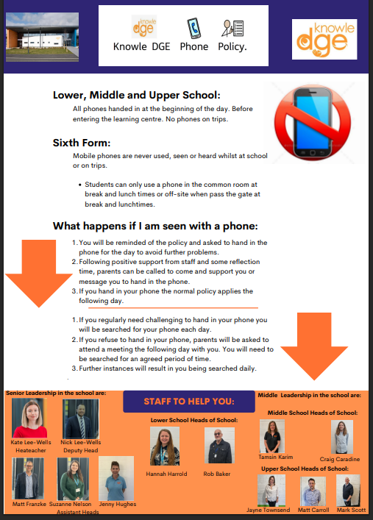

Positive Handling

At Knowle DGE we use positive handling to prompt, guide, reassure and comfort pupils. Examples of this are

- Holding the hand of a child of the child at the front/back of the line when going to assembly or when walking together around the school
- When comforting a distressed young person;
- When a young person is being congratulated or praised;
- To demonstrate how to use a musical instrument or techniques during PE lessons and sports coaching
- To give first aid

On rare occasions we may need to physically intervene with pupils in order to keep themselves, others and the environment safe.

Types of incident where the use of reasonable force may be necessary fall into 3 Broad Categories:

1) Action due to imminent risk of injury
2) Action due to developing risk of injury or significant damage to property
3) Action where a pupil is behaving in a way that is compromising good order and discipline.

Should staff use physical intervention with your child, you will be contacted and informed of the circumstances and the use of positive touch.

Please see Academy “Engagement for Learning Policy”
“Positive Handling Policy”

Knowle DGE academy follow the government guidelines set out by the DfE
“Use of Reasonable Force: Advice for head teachers, staff and governing bodies” 2013

I have read and have been informed that the use of reasonable force / Positive Handling may be used in order to reduce the risk of injury to my child or other pupils and staff, reduce the risk of significant damage to property and to ensure that behaviours are not compromising good order.

Parent/Carer Name:

E-Safety / Internet Usage

Knowle DGE Academy recognises the fundamental benefits that ICT has on our Academy. Electronic use is now embedded in society and our aim is to prepare our young people and wider community to use this medium efficiently and safely.

Knowle DGE has an E-Safety policy and internet usage for staff and pupils. Knowle DGE supervises pupils whilst working on the Academy’s server and internet content is filtered.

Key points : Academy devices used onsite.

- We do not allow the use of instant messaging, blogs, podcasting, social networking sites, video broadcasting, chat rooms, or music download sites. These are filtered websites, and it is requested that pupils do not attempt to access these sites.
- Email accounts are only set up by approved email providers.
- We don’t allow the uploading or downloading of data through our network or onto a PC. We request that any student does not seek to gain access to our network or ISP through any devices.

Although we continually filter and monitor access to websites, we understand that at times, unsuitable sites may be accessed. Knowle DGE will record the site and arrange to have the site filtered immediately. Pupils who fail to adhere to the E Safety policy may lose privileges of using ICT at Knowle DGE for a period of time, the incident will be logged and any sign of cyber bullying will be actioned according to our equality policy. In some circumstances should some activity be a concern we will action this though our Safeguarding Policy and/or inform the police of any criminal activity.

Parent/Carer Name:

Searching, Screening and Confiscation of items

Following DfE guidance “Searching, screening and confiscation advice for Head Teachers, school staff and governing bodies” July 2023.

Knowle DGE under the direction of the Head teacher have a statutory power to search pupils and their possessions without consent if we suspect that a pupil has a prohibited item such as

- Knives or weapons
- Alcohol
- Illegal Drugs
- Stolen Items
- Tobacco / Cigarette papers / lighters / matches
- Fireworks (or flammable liquids and gas)
- Pornographic images / material (including any held on electronic devices)
- Any article that can be seen to or likely to be used to commit an offense or
- To cause personal injury to, or damage to the property of any pupil (including the pupil).

Knowle DGE may also operate screening with a hand held screening device, even if we do not suspect that the pupil has any of the prohibited items listed above.

This is to ensure our expectations of this policy in Health and Safety of all staff and pupils. It is a STATUTORY REQUIREMENT that Knowle DGE report any of the above incidents to the police.

Knowle DGE has a statutory power to confiscate, without consent all of the items listed above.

In addition, Knowle DGE will confiscate any electronic device should we suspect that it contains data or files that breach our E safety policy.

In order to avoid the confiscation of mobile phones, it is our standpoint that Mobile Phones or electronic devices are not permitted on site and therefore are handed in from Key Stage 1 to 4. In Post 16, pupils may have their phones in designated break time areas.

Parent/Carer Name:

Photographs at Knowle DGE

We are really proud of the achievements the young people make and take photos in order to display their engagement and achievements around the Academy.

We also like to be able to share these with parents and carers so you can see all of the fantastic things they are doing through newsletters, the closed facebook group and twitter. Occasionally we also wish to have photographs on our Academy website and in the local newspaper.

We will still photograph all young people for display around the Academy and within classrooms.

Photo usage | X if permission granted
Facebook (closed group to school only families)
Class/school newsletters
Website
Twitter/X
National news/media
Evidence for Learning App (PLIMs) - used to send home for student reports and EHCP evidence.

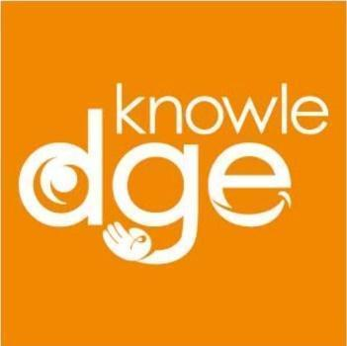
Knowle DGE - Medication and Administration Consent

Student Name:
Date of Birth:
Allergies:
Emergency Contact
(Name, Address, Number)

Medicines to be given in School: (Complete for each medication given)

Name of medicine:
Strength and form of Medicine:
Dose in mg:
Method of administration:
Time to be given:
Medicine is (please circle which applies) | long term / short course / as required
If short course, when does dose end?
Special instructions
(e.g. with food, after food, refrigerated
Storage, needs crushing/dissolving, etc.)

Declaration (by person with parental responsibility for the named child)
I give consent for Knowle DGE to administer the above medication in line
with school policy.
Name: | Relationship  to child: | Signature: | Date:
Learning Contract

As an Academy we will : | As a Young Person at  Knowle DGE I will: | As Parents / Carers we will:
Provide a safe, clean, healthy and motivational environment in which to learn.  Hold individuals accountable for any misuse or damage caused to our Academy.  Promote our ethos of ‘Belief, Respect and Responsibility’. | Follow the Academy’s conduct on behaviour.  Look after my environment and all equipment and Academy property. Be responsible for any damage / breakages caused by myself to the Academy or others within the Academy.  Uphold the Academy’s STANDPOINTS. | Support the Academy in damage procedures and repay any costs involved in any type of damage caused to the Academy or others within the Academy.  Support the Academy in upholding the Academy’s STANDPOINTS (including the management of their mobile phones).
Provide safe and secure provision for personal items.  Search any young person who we suspect as having illegal or dangerous items.  Encourage good attendance through rewards and celebrations. | Be willing to hand over personal belongings that would not be appropriate to carry with me during learning times, including mobile phones.  Attend daily and on time as a proud member of the Knowle DGE community.  Wear the appropriate uniform. Bring the correct kit and equipment for specialised learning. | Support the Academy ‘Amnesty’ procedures and ensure our son / daughter does not bring dangerous or illegal items into the Academy.  Ensure my child always wears the correct uniform for school, including P.E. kit.  Ensure our son / daughter attends daily, punctual and with the right uniform and equipment.  Inform the Academy if our son / daughter will be absent or late.  Attend all meetings that have been set up for our son / daughter (Annual Reviews, Engagement meetings, Restorative, TAC, and PSP’s).

As an Academy we will : | As a Young Person at  Knowle DGE I will: | As Parents / Carers we will:
Communicate with you and inform you of your son / daughter’s progress, achievement and any concerns. We will also communicate with you via telephone, email, letter, text and newsletter | Attend meetings that I have been invited to attend.  Inform home of any important information / pass on newsletters. | Provide the Academy with up to date contact information using the details provided on admission record.
Endeavour to ensure your son / daughter achieves their potential and makes good progress in all areas of learning. We will involve you in all key areas of this journey.  We reward effort, success and achievement. | Engage and participate in all learning opportunities provided within the Academy so I can reach my targets I help to set myself each year. Complete Home Learning activities to enhance my learning. | Participate with Knowle DGE theme days / events and assemblies. To celebrate success and reward achievement.  Attend all parent evenings/meetings and my child’s Annual Review meeting.  Supporting my child in their Home Learning.
Allow parents and careers the opportunity to voice their views / ideas to develop and improve the learning their son / daughter receives. | Feedback my ideas and concerns to Pupil Voice (school council).  Talk to the staff/Learning Facilitator in my Hub if I have any worries/concerns at the Academy. | Inform the Academy immediately should you have any concerns or ideas for development.  Always use the policy on complaints and grievances, as displayed on the website.

Enrichment/Trips

Enrichment activities and offsite visits are a key part of the Knowle DGE curriculum. When a specialised visit is arranged such as Horseworld, Swimming, Duke of Edinburgh etc you will be separately notified and consent requested for this.

However by signing below, you are agreeing to trips such as visits to monuments, parks, other enrichment activities taking place and your child being taken offsite.

Parent/Carer Name:

6th Form Offsite Priviledges

Only pupils in Year 12 and 13 are allowed offsite at lunch and breaktimes. By signing below, you are agreeing to your child having these privileges unless a health and safety risk deems this to be unsuitable.

Parent/Carer Name:

I have read and been informed of all policies and procedures within the induction booklet.

Document | Agreed (Please tick) | Signed by parent/Carer
Positive Handling

E Safety

Searching/Screening & confiscation of items

Photographs (including Website/Twitter/Newspaper)

Enrichment (Offsite visits)

Learning Contracts

Yr 12 and 13 permission to leave site

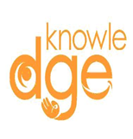
School Uniform Price List - 2025
 | Age  5-6 | Age  7-8 | Age  9-10 | Size  11-13 | Size  XS | Size  S | Size  M | Size  L | Size  XL | Size  XXL
Poloshirt  UC101 / UC103 | £7.21 | £7.21 | £7.21 | £7.21 | £7.85 | £7.85 | £7.85 | £7.85 | £7.85 | £7.85
Sweatshirt  UC202 / UC203 | £9.35 | £9.35 | £9.35 | £9.35 | £10.21 | £10.21 | £10.21 | £10.21 | £10.21 | £10.21
P.E.T. Shirts  SS6 / SS6B | £5.65 | £5.65 | £5.65 | £5.65 | £6.17 | £6.17 | £6.17 | £6.17 | £6.17 | £6.17

 | Age  7-8 | Age  9-10 | Age  11-13 | 32” | 34” | S | M | L | XL
Fleece  RG258 / RG117 | £12.35 | £12.35 | £12.35 | £12.35 | £12.35 | £14.75 | £14.75 | £14.75 | £14.75

