Knowle DGE Academy

Welcome back to the start of Term 5. Term 4 was very busy with an Auschwitz trip for some pupils from Upper School, they represented the academy incredibly well. Lower School had fantastic end of term trips and Middle had another successful Theme Day. We also had a school to school visit from the other SEN Schools in the trust, they were incredibly impressed, in particular with our Post 16 pupils who were able to talk about their school experience and their aspirations for the future. We also had a ‘pop up Book Fair’ where all pupils were able to bring a book home for free. We still have a few available so please let us know if you’d like any more.

At only two weeks into term 5 we’ve already had a busy start with exams for pupils in Upper School and an excellent Duke of Edinburgh camp.

Key Dates
Term Dates
Tuesday 22nd April start of Term 5
Friday 23rd May End of Term 5

Monday 2nd June start of Term 6
Friday 18th July End of Term 6
We are currently finalising 2025-26 dates and will be sharing these shortly.

Celebrations
- Thursday 8th May 2025 VE Day, Pupils can wear clothes for a celebration. Red/White/Blue
- Friday 27th June Sports Day, further details to follow
- Wednesday 9th July 2025 Summer Fair 1-3pm

Individual Hub newsletters will have further details about things coming up in each area of the school and more about what your child is learning.

Celebrations
Pupils have taken part in Duke of Edinburgh trip this term, they were fantastic and were very lucky with such beautiful weather too! On the first day pupils walked 15k! They all had happy but tired faces when returning back to school.
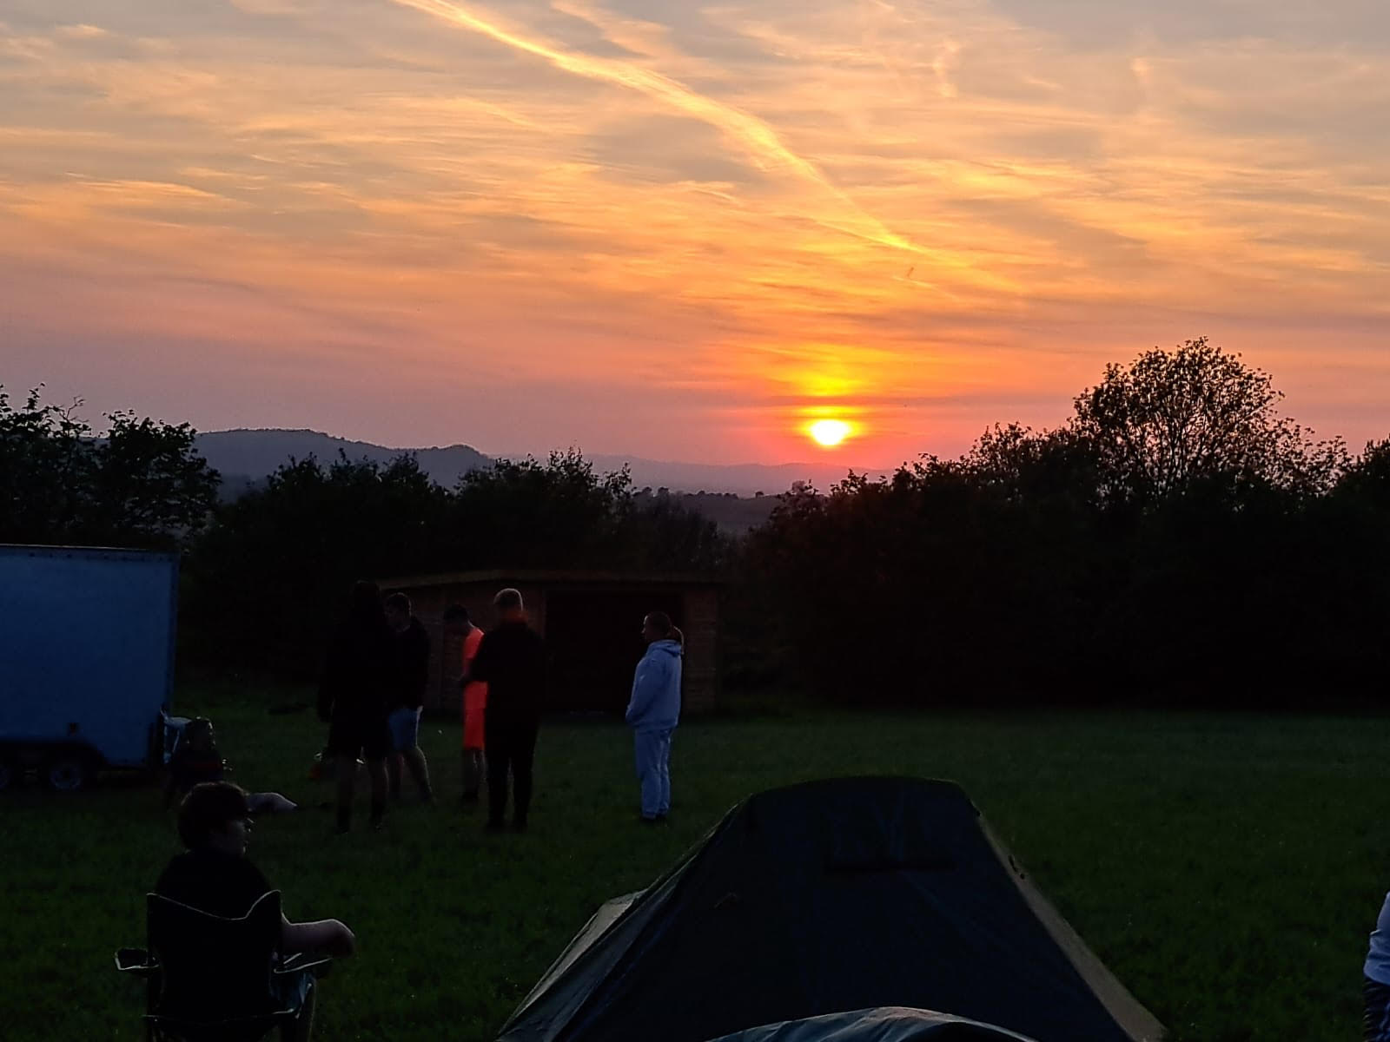

Site Changes
We have had solar panels installed over Easter, this will help reduce our energy bills! As it’s an exciting initiative, we were visited by Bill Esterson, MP over the Easter Holidays to see the work.

We have some fantastic site work planned for the summer holidays which is going to provide excellent enrichment opportunities for the pupils, this includes a BMX track on the back field, a turfed area for the use of scooters and bikes by the Lower School Classes and new climbing apparatus situated between the Upper School Classes and the Lodge.

We are in ongoing discussions with Bristol City Council regarding the adjacent building site and access and hope to be able to share some updates with you soon.

Uniform
Well done to everyone in uniform. Student voice have asked for a T-shirt option and therefore we have ordered a variation of the PE T-Shirt and a sweatshirt option too.

The school uniform is a Navy Polo shirt/T-Shirt and a navy fleece and/or jumper/cardigan. You will have been provided your first one free at induction. Further ones can be purchased via parentpay or free ones are available from the community wardrobe. A range of supermarkets also sell plain navy sweatshirts, T-Shirts and polo shirts. Black trousers or joggers and black shoes or trainers should be worn.

We are aware that with the hot weather pupils may choose to use summer options-Navy or black shorts and blue gingham dresses/shorts are available at most supermarkets.

This uniform applies to all students except Post 16 who have a dress code. We are able to provide spare uniforms on arrival for any pupils who need it. Should finance be a barrier, please contact your form tutor and we may be able to assist.

As the weather is sunnier, please ensure pupils have some sun cream on in the morning. This is especially important for pupils who have outdoor education trips or PE offsite.

Staffing
We officially welcome Andy and Arsena, LFs in Upper School and Lower School to the team.

Attendance
You will know that regular attendance at school is essential in order to ensure your child is able to settle well, establish positive routines and relationships and learn successfully. Please contact the academy if your child is unwell.

Warm wishes,

Kate Lee-Wells
Headteacher

